Contrapositive and Counter Example Workshop

Workshop 1
Conjecture:
Let n ∈ Z. If 15n is even, then n is even.

Assumption:
15n is even

Conclusion:
n is even

Step | Argument for the correctness of the step
If n is odd, then 15n is odd | Contrapositive conjecture
n = 2k + 1 | Definition of odd number
15 * (2k + 1) = 30k + 15 = 2 * (15k + 7) + 1 | Corollary
2 * (k’) + 1 | Define k’ = 15k + 7, which makes it follow the form of an odd number
Contrapositive conjecture is true since both n and 15n is odd | Lemma
Since the contrapositive conjecture is true, the original conjecture is also true. | Proof

Workshop 2
Conjecture:
Let n ∈ Z. If 15n is even, then 9n is even (by using 1)

Assumption:
15n is even.

Conclusion:
9n is even.

Step | Argument for the correctness of the step
Workshop 1 says that n must be even, since 15n is even. Therefore it can be described as  n = 2k | Theorem + definition of even number
9 * (2k) = 2 * (9k) | Corollary
2 * k’ | Define k’=9k, which makes it follow the form of an even number
9n is indeed even, which makes the conjecture true. | Proof

Workshop 3
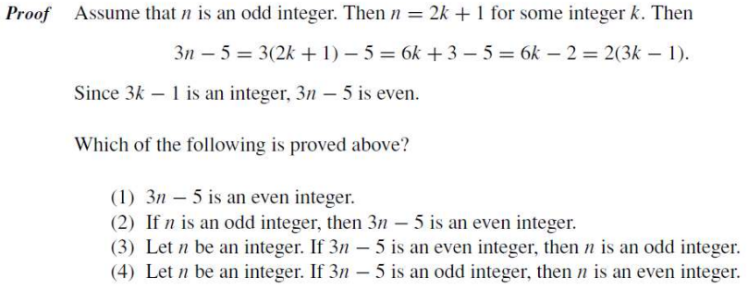

(2) through direct proof
(4) through contrapositive proof

Workshop 4
The equation x⁵ + 2x − 5 = 0 has a unique real number solution between x = 1 and x = 2.
$$x^{5}+2x-5=0$$
$$x^{5}+2x$$

